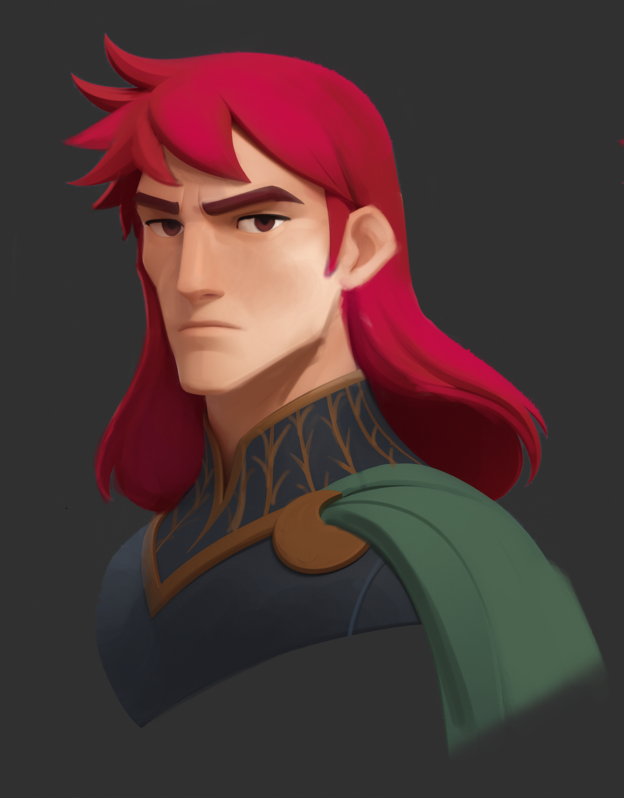
“What are you looking at? Keep walking.”
The first glimpse of what we’re building is hidden, but every path will be worth exploring.
Yes, we’re creating a self-funded original vertical slice.
Every cent from our other activities goes into two things:
A) paying rent.
B) building a compelling demo that will make funding a little easier.
Stay tuned for updates, especially if you like replayable RPGs.

